SKUNK WORKS OPERATING RULES
Developed by Kelly Johnson


1. The Skunk Works' program manager must be delegated practically complete control of his program in all aspects. He should report to a division president or higher.
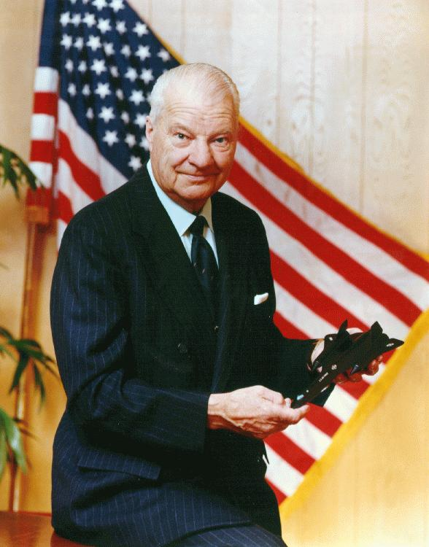


2. Strong but small project offices must be provided both by the military (customer) and industry (contractor).

3. The number of people having any connection with the project must be restricted in an almost vicious manner. Use a small number of good people (10 percent to 25 percent compared to the so-called normal systems).

4. A very simple drawing and drawing release system with great flexibility for making changes must be provided.

5. There must be a minimum number of reports required, but important work must be recorded thoroughly.

6. There must be a monthly cost review covering not only what has been spent and committed but also projected costs to the conclusion of the program. Don't have the books ninety days late and don't surprise the customer with sudden overruns.

7. The contractor must be delegated and must assume more than normal responsibility to get good vendor bids for subcontract on the project. Commercial bid procedures are very often better than military ones.

8. The inspection system as currently used by AD (the Skunk Works) should be used. Push more basic inspection responsibility back to the subcontractors and vendors. Don't duplicate so much inspection.

9. The contractor must be delegated the authority to test his final product in flight. He can and must test it in the initial stages. If he doesn't, he rapidly loses his competency to design other vehicles.

10. The specification applying to the project must be agreed to in advance of contracting. Be sure there is mutual understanding in this field before proceeding; otherwise it takes a mammoth contracting department to unscramble the mess that normally develops.

11. Funding a program must be timely so that the contractor doesn't have to keep running to the bank to support government projects.

12. There must be absolute mutual trust between the military (customer) project organization and the contractor, with very close cooperation and liaison on a day-to-day basis. This cuts down misunderstanding and correspondence to an absolute minimum.

13. Access by outsiders to the project and its personnel must be strictly controlled by appropriate security measures.

14. Because only a few people will be used in engineering and most other areas, ways must be provided to reward good performance by pay, not based on the number of personnel supervised.

15. Never deal with the Navy. (unwritten rule from Ben Rich's memoirs)

