

World News & Analysis

'Donuts-on-a-Rope' Contrail Suggests Flight of Classified Aircraft
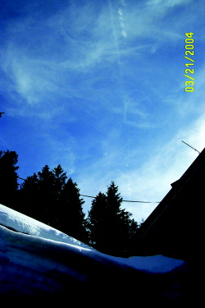
Credit: PHIDIAS CINAGLIA PHOTOS
Aviation Week & Space Technology
04/26/2004, page 29

William B. Scott
Colorado Springs
'Pulser' Back?
After a long absence, what may be a classified aircraft powered by an impulse-type engine appears to be back in the air again. Its distinctive "donuts-on-a-rope" contrail was spotted recently above Utah's Wasatch Mountains.
More than a decade ago, cotton-ball-like contrails were spotted and photographed periodically by observers throughout the U.S., but reports had dropped off sharply in recent years (AW&ST May 11, 1992, p. 62). The latest sighting over Utah on Mar. 21 was of particular interest, though, because the unknown "pulser" apparently was shadowed by another, conventionally powered chase aircraft that left a smooth, unbroken contrail. The two contrails--one smooth, the other a string of puffs--remained parallel across at least 120 deg. of sky, indicative of distinctly different powerplants.
The two contrails were spotted just before 3 p.m. MST by Phidias Cinaglia, a mechanical engineer who lives in the mountains east of Salt Lake City. He did not see or hear the two aircraft fly overhead. However, he noticed the contrails very soon thereafter, because they were still well defined. Initially, he saw distinct side-by-side puffs, suggesting a twin-engine aircraft with powerplants firing simultaneously. Cinaglia remarked that each of the impulse contrails was "an unbroken string of pearls" across a large arc of the sky.
In the 2-3 min. required to run into his house and grab a camera, the side-by-side puffs had merged, and the contrails were rapidly dissipating (see photos). Nonetheless, his photos show clear differences between contrails of the two aircraft.
Cinaglia's home is at 8,000-ft. elevation, and the clear mountain air and afternoon Sun angle enabled an exceptionally clear view of the pulser's contrail structure. He said distinct, horizontally separated puffs were clearly visible initially, and each puff displayed well-defined "residual vortex" patterns. He suggested that "whoever designed the engine control system did an excellent job," because both powerplants were firing at exactly the same time.
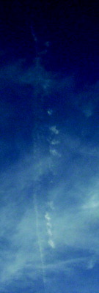
Credit: PHIDIAS CINAGLIA PHOTOS

